QUESTION NO 2

Date 22/07/2024

QUESTION Read two numbers and interchange the values using three logics

/\*\*\*\*\*\*\*\*\*\*\*\*\*\*\*\*\*\*\*\*\*\*\*\*\*\*\*\*\*\*\*\*\*\*\*\*\*\*\*\*\*\*\*\*\*\*\*\*\*\*\*\*\*\*\*\*\*\*\*\*\*\*\*\*\*\*\*\*\*\*\*\*\*\*\*\*\*\*  
 Author : NANDHANA ANILKUMAR  
 Roll no : 29  
 Semester :1   
 programme :BCA  
 Question :Read two numbers and interchange the values using three logics \*\*\*\*\*\*\*\*\*\*\*\*\*\*\*\*\*\*\*\*\*\*\*\*\*\*\*\*\*\*\*\*\*\*\*\*\*\*\*\*\*\*\*\*\*\*\*\*\*\*\*\*\*\*\*\*\*\*\*\*\*\*\*\*\*\*\*\*\*\*\*\*\*\*\*\*\*\*\*/

a) #include<stdio.h>

int main()

{

int first,second,temp;

print(“\tenter two number:”);

scanf(“%d%d”,&first,&second:”);

temp=first;

first=second;

second=temp;

Printf(“\tfirst no=%d\n”,first);

Printf(“\tsecond no=%d”,second);

return 0;

}

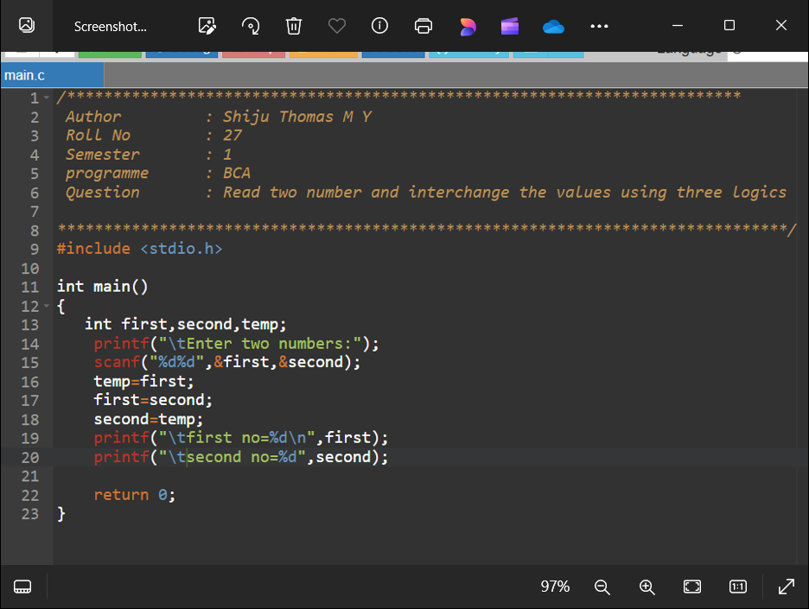

OUTPUT

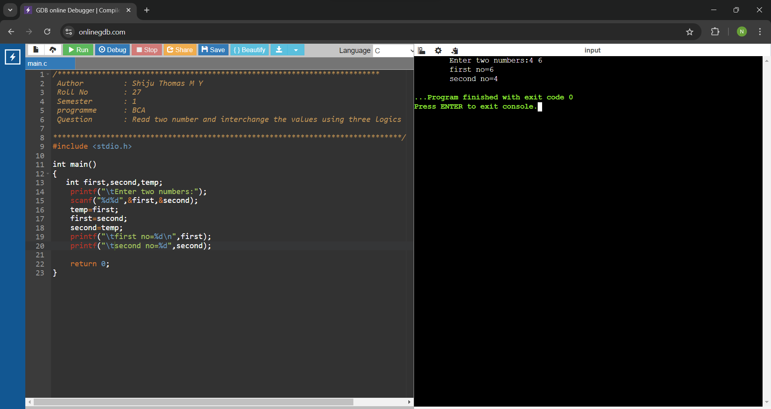

b)

#include <stdio.h>

int main()

{

int first,second;

printf("\tEnter two no:");

scanf("%d%d",&first,&second);

first=first+second;

second=first-second;

first=first-second;

printf("\tfirst=%d\n",first);

printf("\tsecond=%d",second);

return 0;

}

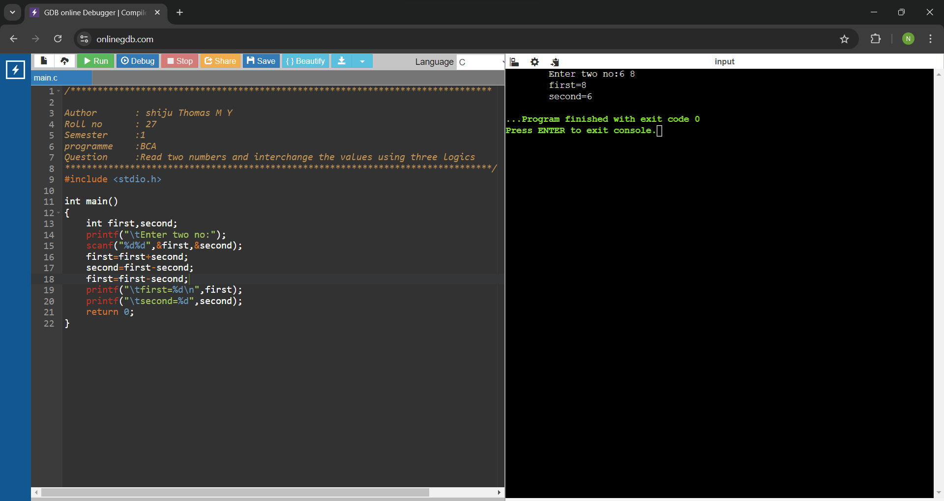

OUTPUT



C)

#include <stdio.h>

int main()

{

int first,second;

printf("\tEnter two no:");

scanf("%d%d",&first,&second);

first=first^second;

second=first^second;

first=first^second;

printf("\tfirst=%d\n",first);

printf("\tsecond=%d",second);

return 0;

}

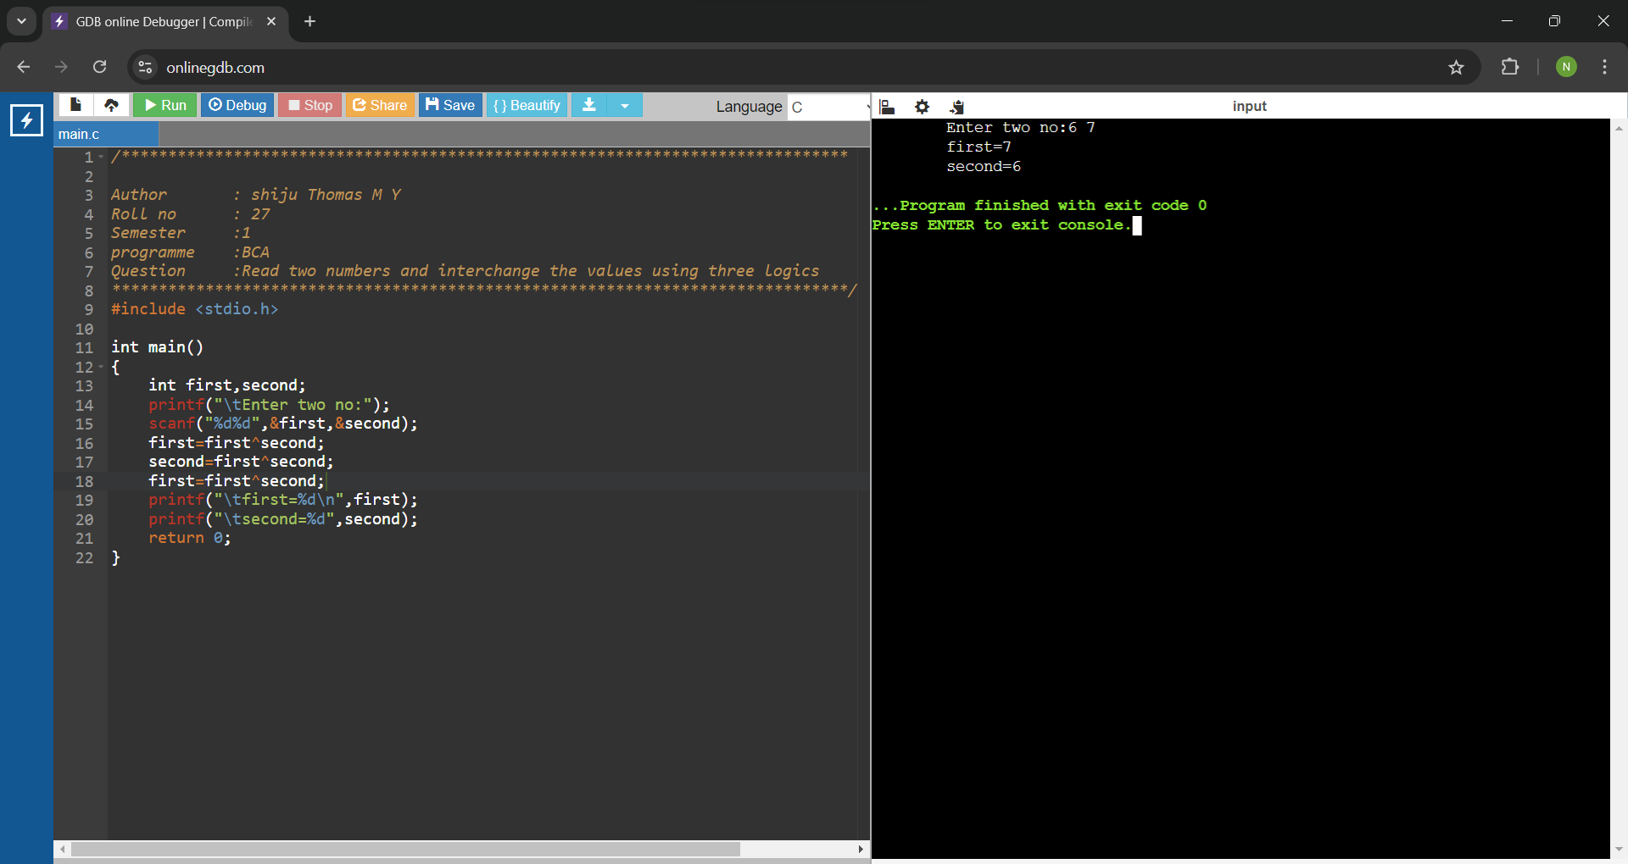

OUTPUT

